Research - ICOM 4998 (March 15-19)

Solar District Cup

Jeziel E. Torres Vazquez

Email: [jeziel.torres1@upr.edu](mailto:jeziel.torres1@upr.edu)

**Abstract:** This week I had a meeting with Angel to continue the work with the PV mounts. We search for the best PV mount for our needs and specs.

**1 Introduction**

Solar systems have a lot of parts. You need the solar panels, battery, inverter, cables, connections and a lot more. This week I had a meeting with one of the members of the team, Angel Figeuroa. We search and discuss solar mounts. Our task is to search and find the best solar PV fixed mount for our solar arrays. This search required all the information on the solar panels, roofs and more. With this information we started to look and identified the best mounts for the PV arrays.

**2 Work done in the week**

Solar panel mounts are important for solar systems. This makes the panels have better efficiency making them have an angle. This is good for them because they can generate more energy that way. Also, it is important to use good mounts. This will make a better solar array and protect them from snow and wind.

In the meeting with Angel we started by discussing the angel. The design team made a file that contained all the outputs from a specific angle. With this information we can check if the mount can do the expected angles. This is very important for the design because depending on the angle the power of the PV can increase and decrease. We search for the angle with the most optimal and power produced. This angle was 10°.

The panels the design team opted for the “SunPower 430–450 W Commercial A-Series Panels”. These panels are big and we need to search for a mount that can hold them nicely. The other important part for this search is the wind and snow load. This information is especially important for the research because this system is going to be built in Denver, Colorado. Denver has wind because of snow storms and snow because Denver is a cold place. For this information we search on Denver government internet sites and other more. We found that Denver has a wind load requirement of 115 to 140 mph. The snow load required to be fullfill is 30 psf. This information is very important because we need to provide a system that can handle strong weather without any problems.

The last information needed to find the perfect solar mount is the warranty. Because of the scale of the project, the competition asks for a 25 year system that can handle everything in the Campus. We search every important company that we list as a good candidate. With all this in mind, Angel and I found a company that has really good products and a good reputation. The solar mount they sell is a fixed solar mount made from aluminum and rails to mount the PV arrays. They had a wind load of 134mph and a snow load of 31.33psf. The warranty they offer is 20 years. We email the company and we are waiting for a response. This mounts angle can go from 10° to 60°

**3 Graphs, tables, and picture**

Here is the solar mount and the specs:

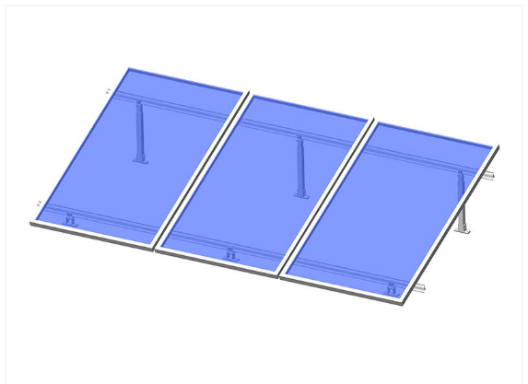

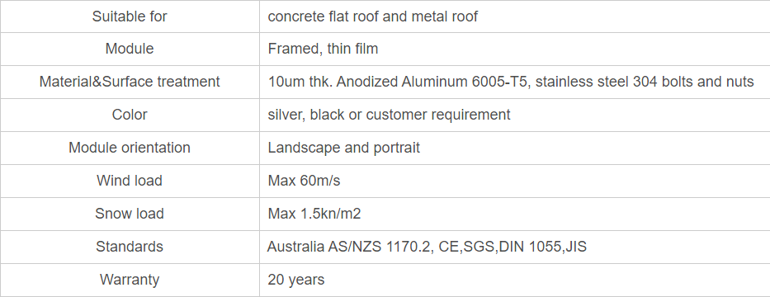

**4 Conclusion**

The solar panel mount is a very important part of the system we are building for the competition. There is a lot of information to be checked and studied before even searching for the panel mount. With all of this information you can pick the best mount that fits your needs. It will take a lot of stress to mount your panels and then they don't work as intended. Because of this we did all the research to find the best PV mounts. The ArtSign mounts provided everything we were looking for. The angle, wind and snow loads and the long warranty. The only thing left is to receive information from the company to check the price and the amounts of mount we need for our solar panels arrays.